Accounting
2014 – Question 5

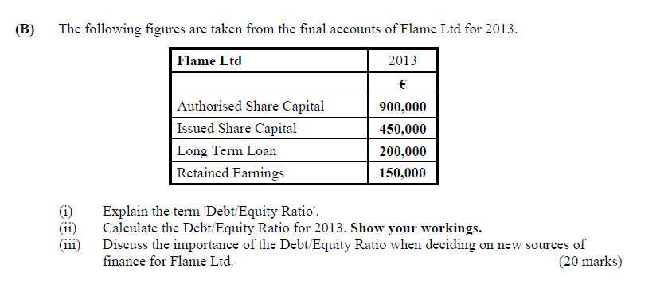

2012, Question 5

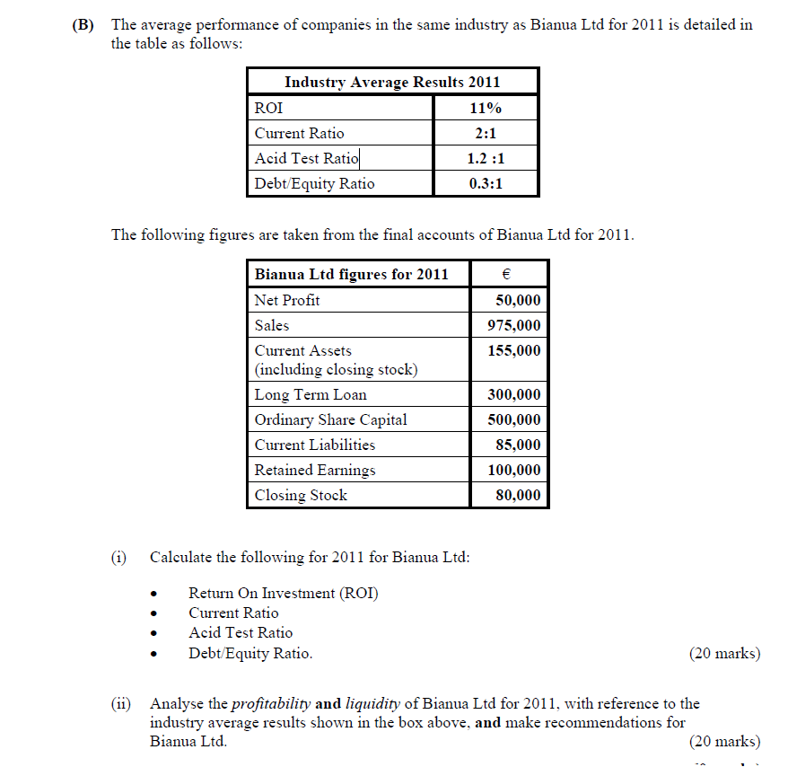

2011, Question 5
xxxxxxxxxxxxxx

2010, Question 5

2009, Question 5

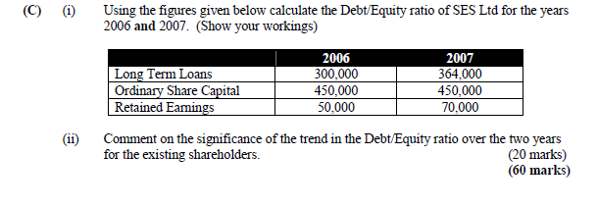
2008, Question 5
xxxxxxxxxxxxxx
2007, Question 6
(C) Liquidity ratios are used to assist in managing a business. Name two of these ratios and
describe their respective benefits.
(20 marks)
2006 Question 5
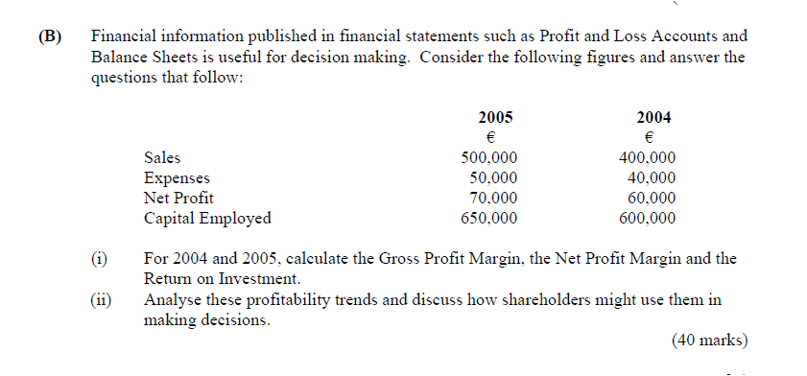

2004, Question 5
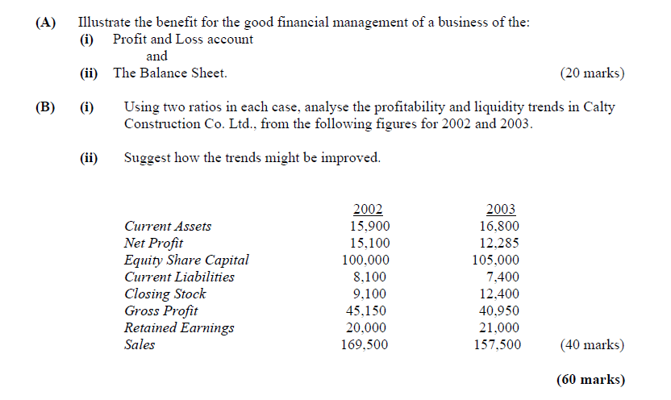
2003, Question 5
xxxxxxxxxxxxxx
2002, Question 5
Xxxxxxxxxxxxxx

2001, Question 6
