Economics Test - Government

- – 2010 Q6
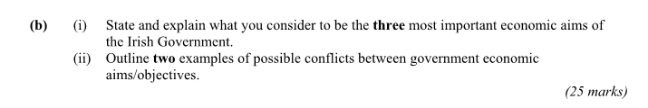
(B)
At end of December 2008 the Irish National Debt amounted to approximately €50.4bn and at the end of December 2014 it was approximately €180bn.
State and explain three problems associated with the Irish National Debt.
(15 marks)

(C)
- Explain Adam Smith’s four canons of taxation

(D)
- Define the exchequer borrowing requirement
- Explain, with an example, what is meant by the incidence of taxation
- State three functions of the National Treasury Management Agency
[30 marks]

