**Insurance and Tax**

**2014 Question 5**

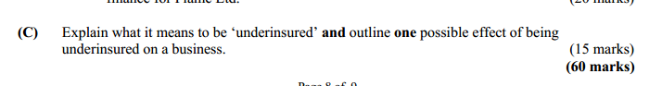

**2012 Question 5**

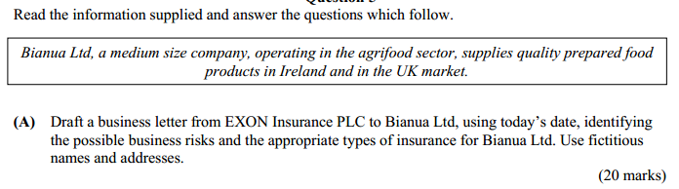

**2011 Question 5**

(B) Pay As You Earn (PAYE), Value Added Tax (VAT), and Corporation Tax are examples of

taxes relevant to a business.

(i) Explain **each** tax underlined above.

(ii) Evaluate the implications of **each** tax for a business.

(25 marks)

(C) (i) Illustrate your understanding of the term ‘risk management’.

(ii) Describe **three** methods a manager might consider to minimise risk within a business.

(20 marks)

***2008*** Question ***6***

**(B)** (i) Explain the term ‘risk management’.

(ii) Illustrate **three** methods that can be used to reduce risk in a business. (20 marks)

***2007 Question 5***

**(A)** Distinguish between the following taxation forms: *Form P21* and *Form P60*.

(20 marks)

(B)From the following information, calculate the net annual take-home pay of Ms. Joan

McCormack.

Joan McCormack is an employee of Lynch Printers Ltd and earns a gross annual salary of

€84,000.She is allowed the following tax credits: Single Person credit of €1,760 and PAYE credit of €1,760. The income tax rates are: 20% on the first €34,000 (standard rate cut-off point) and 41% on the balance. The employee PRSI rate (including the health levy) is: 6% on the first €48,800 and 2% on the balance.

(20 marks)

***2006 Question 5***

**(A)** (i) Differentiate between indemnity and insurable interest. Illustrate your answer.

(ii) Distinguish between insurance for a household and for a business.

(20 marks)

***2002 Question 5***



***2001 Question 5***

'Capdata' is a small software writing business located in the south of Ireland and employing four employees. It has the opportunity to grow but has little experience of the day to day reality of running a business. It needs premises, equipment and employees not only with computer technology skills but also with businessmanagement and sales skills.

(B) Describe what is meant by Risk Management.

Illustrate a method that 'Capdata' could use to reduce risks to the business. (20 marks)

(C) Describe the taxes that 'Capdata' would be liable for. Give reasons for your choice. (20 marks)

**(60 marks)**